|  |  |  |
| --- | --- | --- |
| **Sr. No.** | **Contents** | **Page No.** |
| **1** | **Annexure I– Micro Project Proposal** | **1-2** |
| 1.Aims/Benefits of the Micro-Project | 1 |
| 2. Course Outcome Addressed | 1 |
| 3.Proposed Methodology | 1 |
| 4. Action Plan | 2 |
| 5. Name of Team Members with Roll No.’s | 2 |
| **2** | **Annexure II – Micro Project Report** | **3-18** |
| 1.Rationale | 3 |
| 2.Aims/Benefits of the Micro-Project | 3 |
| 3.Course Outcome Achieved | 3 |
| 4. Literature Review | 3 |
| 5.Actual Methodology Followed | 4-12 |
| 5.1 Used Component | 13 |
| 5.2 Circuit Diagram | 14 |
| 6.Actual  Resources Used | 15 |
| 7.Outputs of Micro-Projects | 15 |
| 8. Skill developed / Learning out of this Micro-Project | 16 |
| 9. Applications of this Micro-Project | 16 |

**Annexure I**

**Micro Project Proposal**

**“AND and OR Gates”**

**1. Aims/Benefits of the Micro:**

1. The basic logic gates are used to perform fundamentallogical functions**.**

2. Basic gates are the electronic circuits in a digital system.

3. All digital system constructed by only basic gates.

**2. Course Outcome Addressed:**

1) CO1-Use number system and codes for interpreting working of digital system.

2) CO2- Build simple combinational circuits.

**3. Proposed Methodology:**

Logic gates are the basic components of any digital system. Logic gates are the electrical circuit with only one output and one or more inputs. A specific logic governs the relationship between the input and the output. AND gate, OR gate, NOT gate, and so on are examples of logic gates etc.

**4. Action Plan**:

|  |  |  |  |  |
| --- | --- | --- | --- | --- |
| Sr.  No. | Details of Activity | Planned  Start date | Planned  Finish date | Name of Responsible Team Members |
| 1 | Search the topic | 29/08/2022  1:00pm-3:00pm | 05/09/2022  1:00pm-3:00pm | Akshay Dashrath Gitte |
| 2 | Search the information | 12/09/2022  1:00pm-3:00pm | 19/09/2022  1:00pm-3:00pm | Harsh Moreshwar Kale |
| 3 | Material Gathered | 26/09/2022  1:00pm-3:00pm | 03/10/2022  1:00pm-3:00pm | Akshay Dashrath Gitte |
| 4 | Logic developing | 10/05/2022  1:00pm-3:00pm | 15/10/2022  1:00pm-3:00pm | Harsh Moreshwar Kale |
| 5 | Circuit making | 31/10/2022  1:00pm-3:00pm | 07/11/2022  1:00pm-3:00pm | Akshay Dashrath Gitte |
| 6 | Implementing the Circuit | 14/11/2022  1:00pm-3:00pm | 21/11/2022  1:00pm-3:00pm | Sujit Sudhakar Sukane |
| 7 | Testing and Correction | 28/11/2022  1:00pm-3:00pm | 05/12/2022  1:00pm-3:00pm | Akshay Dashrath Gitte |
| 8 | Finalizing Project with its report | 12/12/2022  1:00pm-3:00pm | 19/12/2022  1:00pm-3:00pm | Sujit Sudhakar Sukane |

**5.Names of Team Members with Roll No.’s:**

|  |  |  |  |
| --- | --- | --- | --- |
| **Sr.**  **No.** | **Enrollment No.** | **Name of Team Member** | **Roll No.** |
| 1 | 2110950049 | Mr. Akshay Dashrath Gitte | 01 |
| 2 | 2110950051 | Mr. Harsh Moreshwar Kale | 03 |
| 3 | 2110950159 | Mr. Sujit Sudhakar Sukane | 60 |

**Ms. Pallod P.G.**

**Name and Signature of the Teacher**

**Annexure – II**

**Micro-Project Report**

**“AND and OR Gates”**

1. **Rationale:**

We made a circuit using AND and OR gates. To check how they work after giving a supply.

**2. Aims/Benefits of the Micro-Project:**

1. The basic logic gates are used to perform fundamentallogical functions**.**

2. Basic gates are the electronic circuits in a digital system.

3. All digital system constructed by only basic gates.

**3. Course Outcomes Achieved:**

1) CO1- Use number system and codes for interpreting working of digital system.

2) CO2- Build simple combinational circuits.

**4. Literature Review:**

First we took subject from teacher assigned to us create a project on Basic Gates. Then we searched topic on the google that how to create a test cases for any app Then then we got lot of information related to our project then we started creating taste .cases for Basic Gates .while creating test cases we got some difficulties then we took then help of teacher related to that subject helped us solving our difficulties then we started implementing our project.

**TYPES OF BASIC GATES**

1. **AND Gate**

The AND gate plays an important role in the digital logic circuit. The output state of the AND gate will always be low when any of the inputs states is low. Simply, if any input value in the AND gate is set to 0, then it will always return low output (0).

The logic or Boolean expression for the AND gate is the logical multiplication of inputs denoted by a full stop or a single dot as

A.B=Y

The value of Y will be true when both the inputs A and B are set to true.

Types of Digital Logic AND Gate

The AND gate is classified into three types based on the input it takes. These are the following types of AND gate:

The 2-input AND Gate

This is the simple formation of the AND gate. In this type of AND gate, there are only two input values and an output value. There are 22=4 possible combinations of inputs. The truth table and logic design are given below:

**Logic Design**

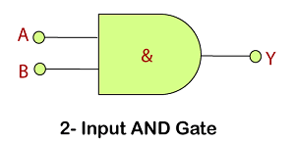

**Truth Table**

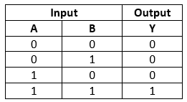

The 3-input AND Gate

Unlike 2-input AND gate, the 3-input AND gate have three inputs. The Boolean expression of the logic AND gate is defined as the binary operation dot(.). The AND gate can be cascaded

together to form any number of individual inputs. There are 23=8 possible combinations of inputs. The truth table and logic design is given below:

**Logic Design**

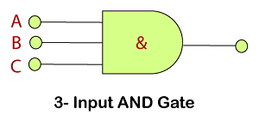

**Truth Table**

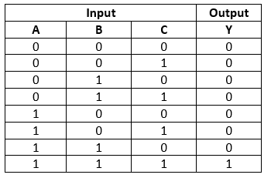

The Multi-input AND Gate

In digital electronics, we can form n-input AND gate also. If there are n inputs, then (N/2)+1 AND gates will be used.

**For example:**

If we have 6 inputs A, B, C. D, E, F, then 4 AND gates are used in the logic design of 6-input AND gate. There is the following expression of the 6-input AND gate:

Y = (A.B).(C.D).(E.F)

In simple words, it is expressed as:

Y=A AND B AND C AND D AND E AND F

**Logic Design**

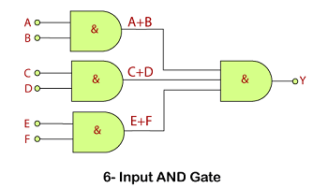

**Truth Table**

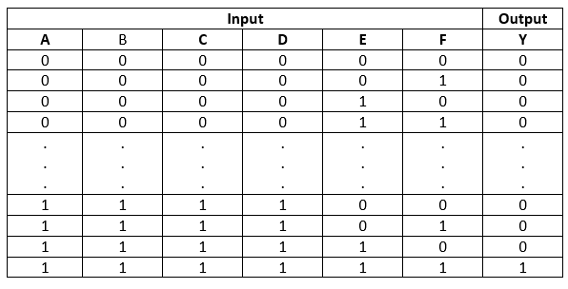

**IC 7408**

**IC 7408 is a logic gate IC**. It consists of four two-input AND Gates. The AND gate perform logical AND operation. Logic gates come in form of ICs. The all four AND gates are independent. Each gate has three pins two inputs and one output. IC 74HC08, IC DM7408 are AND gate ICs.

**Pin diagram of IC 7408:**

The IC 7408 has total fourteen pins including ground and Vcc. The simple pin diagram is shown below.  
The internal structure of IC 7408:

The internal structure of the IC 7408 is shown it consists of four AND Gates.  
[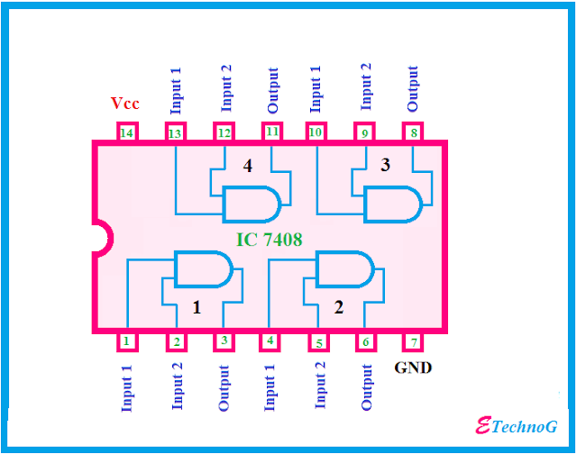](https://1.bp.blogspot.com/-8SEvhlfT89s/XFG_wCG9xuI/AAAAAAAABL4/oekBjN9BJNcT98MbAKcvSaQp2iWMi7s_gCLcBGAs/s1600/IC+7408+internal+structure.png)

Pin Description of IC 7408:

**Pin 1:** The pin 1 is the 1st input for 1st AND Gate.

**Pin 2:** Pin 2 is the 2nd input of 1st AND Gate.

**Pin 3:** Pin 3 is connected to the output of the 1st AND Gate.

**Pin 4:** Pin 4 is the 1st input of the 2nd AND Gate.

**pin 5:** Pin 5 is connected to the 2nd input of the 2nd AND Gate.

**Pin 6:** Pin 6 is connected to the output terminal of the 2nd AND Gate.

**Pin 7:** Pin 7 is the ground pin, it is used to provide power supply to the IC.

**Pin 8:** It is the output pin of the 3rd AND Gate.

**Pin 9:** It provides the 2nd input pin for the 3rd Gate.

**Pin 10:** It is the 1st input pin of the 3rd AND gate

**Pin 11:** Output of the 4th AND Gate.

**Pin 12:** It is connected to the 2nd input of the 4th Gate.

**Pin 13:** The pin 13 is connected to the 1st input of 4th Gate.

**Pin 14**: It is the Vcc ter

minal of the IC, it is used to provide the power supply to the IC chip.

OR Gate

The OR gate is a mostly used digital logic circuit. The output state of the OR gate will always be low when both of the inputs states is low. Simply, if any input value in the OR gate is set to 1, then it will always return high-level output(1).

The logic or Boolean expression for the OR gate is the logical addition of inputs denoted by plus sign (+) as

A+B=Y

The value of Y will be true when one of the inputs is set to true

Just like AND gate, the OR gate is also classified into three types based on the input it takes. These are the following types of OR gate:

The 2-input OR gate

This is the simple form of the OR gate. In this type of OR gate, there are only two input values and an output value. There are 22=4 possible combinations of inputs. The truth table and logic design are given below:

**Logic Design**

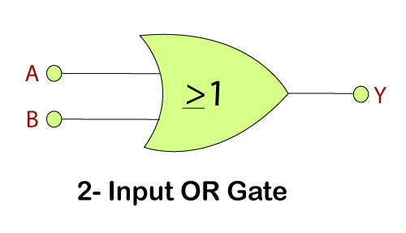

**Truth Table**

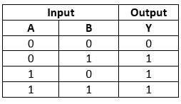

The 3-input OR gate

Just like AND gate, the OR gate can also have any number of individual inputs. The Boolean expression of the logical OR gate is defined as the binary operation plus(+). Like AND gate, OR gate can also be cascaded together to form any number of individual inputs. There are 23=8 possible combinations of inputs. The truth table and logic design are given below:

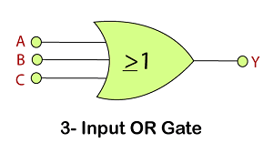

**Truth Table**

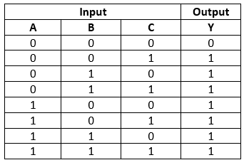

The Multi-input OR Gate

The n-input OR gate can also be formed. If there are n inputs, then (N/2)+1 OR gates will be used.

**For example:**

If we have 6 inputs A, B, C. D, E, F, then 4 OR gates are used in the logic design of the 6-input OR gate. There is the following expression of the 6-input OR gate:

Y = (A+B)+(C+D)+(E+F)

In simple words, it is expressed as: Y=A OR B OR C OR D OR E OR F

**Logic Design**

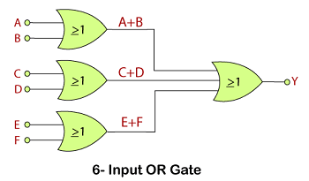

**Truth Table**

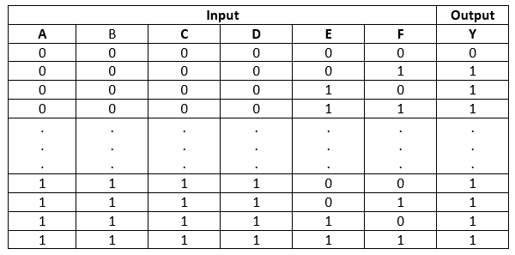

IC 7432

**IC 7432 is a logic gate IC which** consist of four OR Gates. The OR gate performs logical OR operation. The OR gates come in form of  DIP package ICs. Each gate has three terminal two inputs and one output. The ICs are made by CMOS, TTL technology.

### Pin Diagram of IC 7432:

The IC 7432 has fourteen pins like other logic gates ICs. The pin diagram is shown below.

[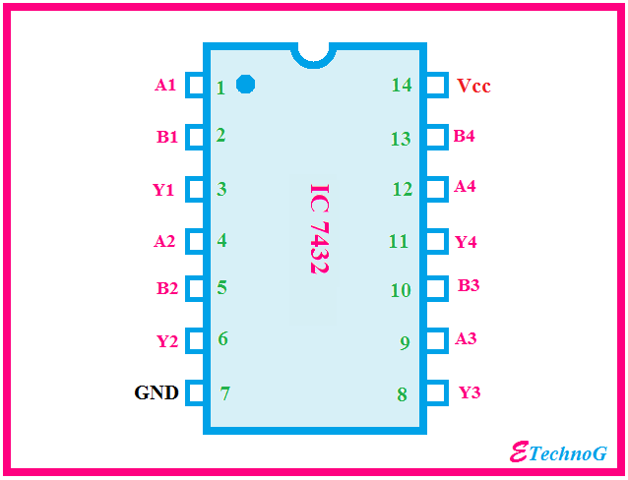](https://4.bp.blogspot.com/-QXkg2GHttuk/XFKJd3xgzgI/AAAAAAAABMI/PxWAf0DG1S8EJ1s4b4MXYBAWM04WRtWFQCLcBGAs/s1600/IC+7432+pin+diagram.png)

### Operating Condition of IC 7432:

* The power supply should be given to the IC from 4.5V DC to 5.25V DC
* The IC will consider a signal as high if the voltage of the signal is above 2V
* The IC will consider a signal as low if the voltage of the signal is below 0.8V
* The operating temperature of the IC should be below the 70-degree centigrade

#### Characteristics:

1. IC 74LS04 can deliver -0.4 mA current when the output is high.
2. It can deliver 16 mA current when the output is low.
3. When the Vcc is maximum and the input signal is 5V then the IC draws 1 mA current.
4. When the Vcc is maximum and the input signal is 2.7V then the IC draws 20 to 40 micro-ampere currents.
5. When the Vcc is maximum and the input signal is 0.4V  then the IC draws -1.6 mA current.

### The internal structure of IC 7432:

As I told before that the IC 7432 consist of four OR Gates, you can also see in the below figure.

The all OR Gates are independent.

[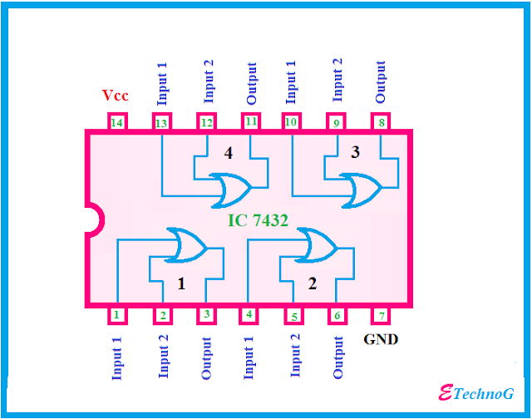](https://3.bp.blogspot.com/-Zx1WubKvq7I/XFKJroNHRkI/AAAAAAAABMQ/OwBp2JRnciAjFvMuOPSkgfVbSAJpIl7AgCLcBGAs/s1600/IC+7432+internal+structure.png)

Pin Description of IC 7432:

|  |  |
| --- | --- |
| **Pins** | **Description** |
| **Pin 1** | It is connected to the Input(A) of OR Gate 1 |
| **Pin 2** | Input(B) of OR Gate 1 |
| **Pin 3** | It is connected to the Output(Y) of OR Gate 1 |
| **Pin 4** | Input(A) of OR Gate 2 |
| **Pin 5** | Input(B) of OR Gate 2 |
| **Pin 6** | This pin provides the Output(Y) of OR Gate |
| **Pin 7** | Ground Pin which used to provide the power supply to the IC. |
| **Pin 8** | It is connected to the Output(Y) of OR Gate 3 |
| **Pin 9** | It is connected to the Input(A) of OR Gate 3 |
| **Pin 10** | Input(B) of OR Gate 3 |
| **Pin 11** | It is the output(Y) pin of the OR Gate 4 |
| **Pin 12** | It is the input(A) pin of the OR Gate 4 |
| **Pin 13** | It is the input(B) pin of the OR Gate 4 |
| **Pin 14** | It is Vcc pin which used to provide the power supply to the IC. |

**5. Actual MethodologyFollowed:**

**5.1 Used Component**

**1. AND Gate IC (7408)**

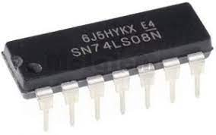

**2. OR gate IC (7432)**

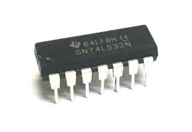

**4.Bread board**

[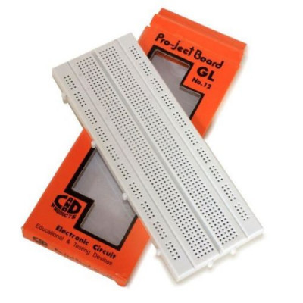](https://www.electronicscomp.com/image/cache/catalog/gl-12-bread-board-800x800.jpg)

**5. Battery**

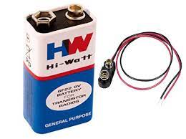

* 1. **Circuit Diagram:**

**OR Gate Circuit Diagram :**

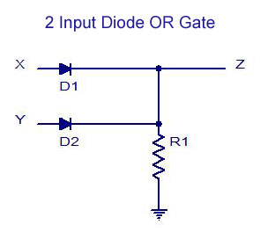

**AND Gate Circuit Diagram :**

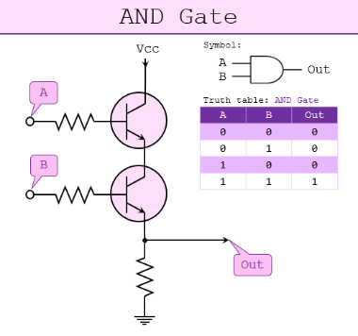

* 1. **Working/Truth table**

**OR GATE:-**

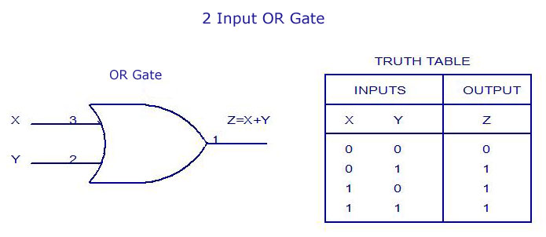

**AND GATE:-**

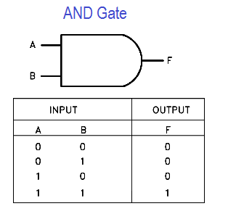

**6. Actual Resources Used:**

|  |  |  |  |  |
| --- | --- | --- | --- | --- |
| **Sr.**  **No.** | **Name of resource / material** | **Specification** | **Quantity** | **Remarks** |
| 1 | IC | 7432, 7408 | 1 |  |
| 2 | LED | Red color | 1 |  |
| 3 | Connecting wires | 0.6mm | 10 |  |
| 4 | Breadboard | 5.5 x 17cm | 1 |  |
| 5 | Battery | 9v | 1 |  |

**7.Outputs of Micro-Projects:**

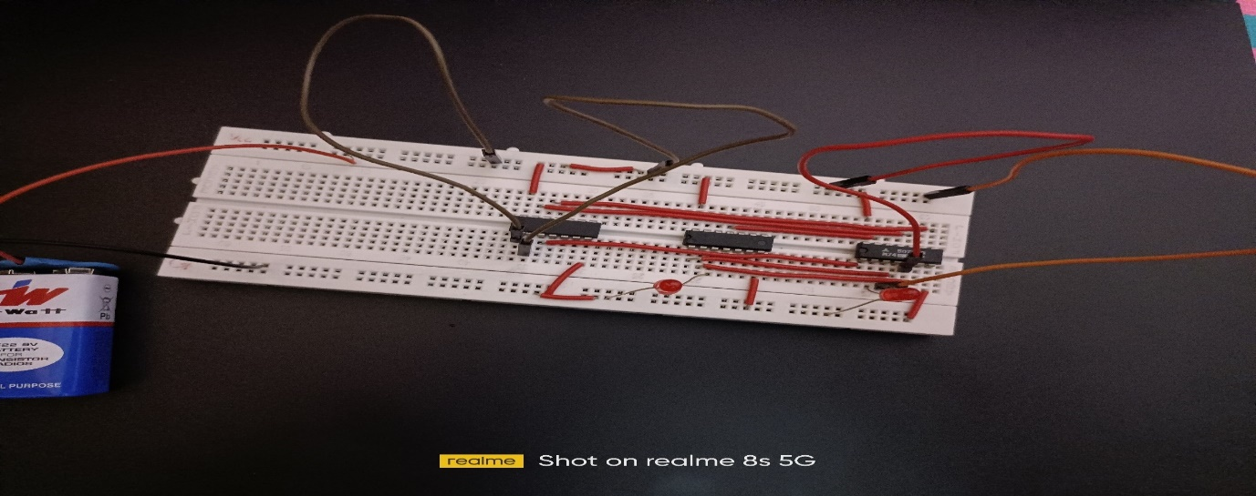

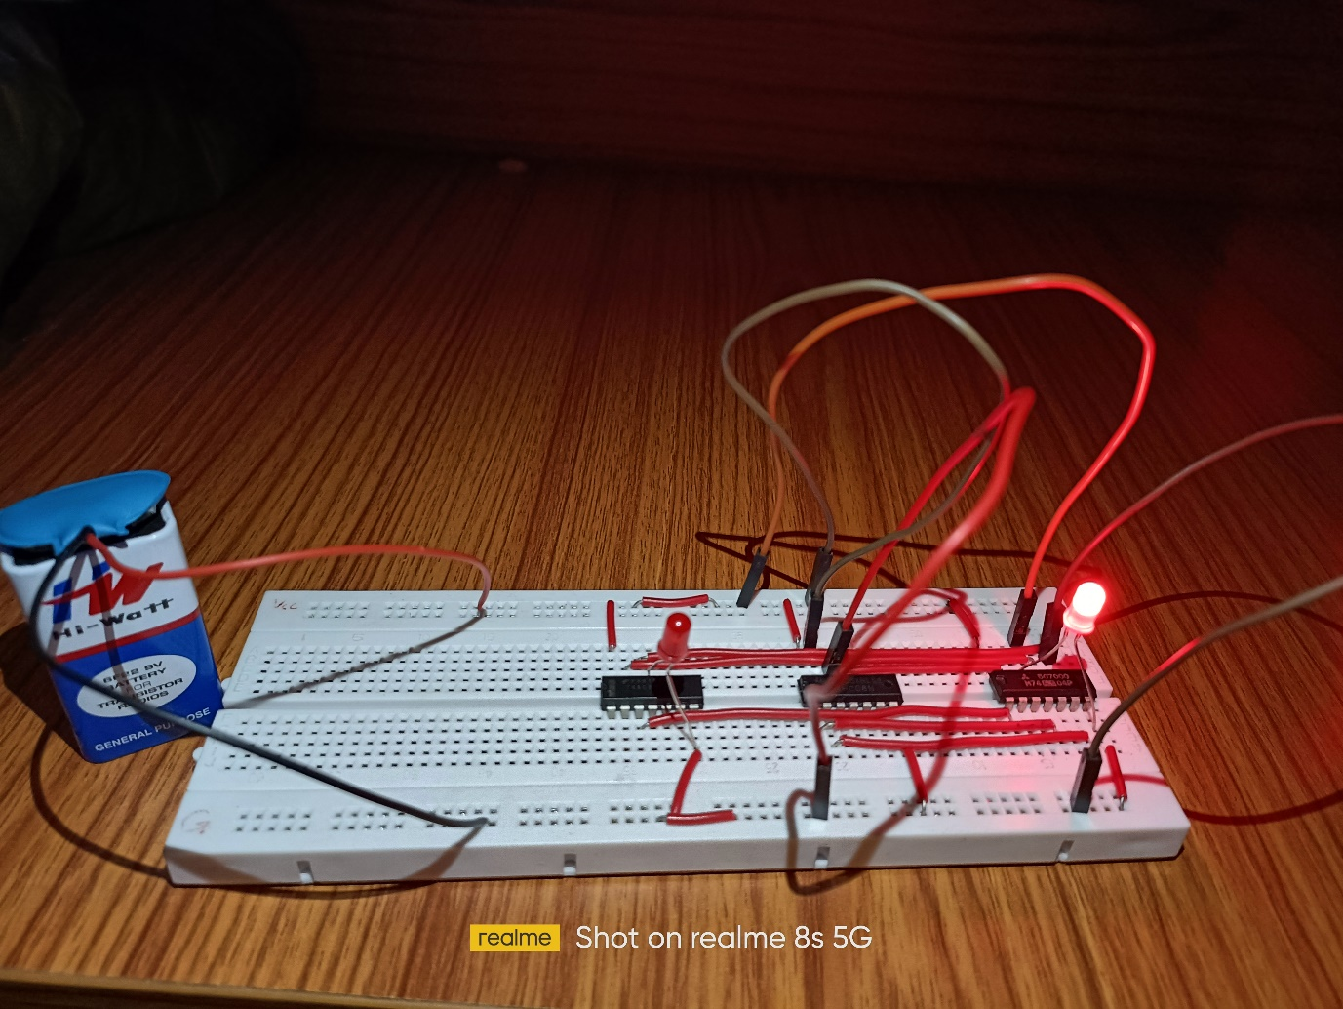

**8. Skill developed / Learning out of this Micro-Project:**

There are so many thing that we learn from this project of

1. We learn that how to make the project on breadboard.

2. How to test a circuit.

. How to collect the information and how to make the presentation that we learn from this project.

4. We learn to use IC’s in digital techniques.

5. This all thing we learn from this project.

**9. Applications of this Micro-Project:**

1. It can be used to learn how to test circuit by using Breadboard.
2. It can also be used to learn some work of different IC’s like AND gate OR, NOT gate IC.
3. For Educational Purpose.

*********